Blog #1: When it comes to the Bullpen, Maybe Relieve the Bank Account
Hello reader,
Given the acquisition of Edwin Diaz by the Dodgers for a whopping $23M AAV as arguably the biggest story coming out of winter meetings last week, the back-to-back World Series champs are now proud owners of the largest relief pitching contract on an AAV basis, and 2 of the top 3 total value reliever contracts in the MLB. Tanner Scott and Edwin Diaz will combine for $141M in payroll for the upcoming season, with a major question hanging in the balance: how can a relief pitcher be worth so much? It is no doubt relievers are an important part of the game of baseball. A tweak on the adage may even say bullpens win championships, and I would tend to agree with that statement. But really, what kind of value can you derive from giving a huge contract with no guarantee it’ll pay off? Let’s dive a bit deeper.
Including Edwin Diaz, there are currently 18 relief pitchers in the league making $10M+ AAV, 9 of which have signed this offseason. As large-market teams push salaries higher to secure elite talent, forcing league-wide adjustment, the central issue is whether the production justifies the investment. To answer the question at hand, I’d like to do a case study. Excluding the players who signed contracts this year, below is the list of 9 relievers making $10M+ AAV along with the year they signed:
- Josh Hader (2024) - $19.0M AAV
- Tanner Scott (2025) - $18.0M AAV
- Carlos Estevez (2025) - $11.1M AAV
- A.J. Minter (2025) - $11M AAV
- Blake Treinen (2025) - $11M AAV
- Robert Stephenson (2024) - $11M AAV
- Jeff Hoffman (2025) - $11M AAV
- Jordan Hicks (2024) - $11M AAV
- Andrew Kittredge (2025) - $11M AAV
Looking at this group, all of whom have signed within the past 2 seasons, we have a basis for comparison. Using 6 of the above players (Minter and Stephenson did not pitch enough innings due to injury and Hicks had a stint as a starting pitcher, conflating his stats) we can dive into their major statistics to see their performance before and after their big pay day.

Part I: The Year Before Their Contract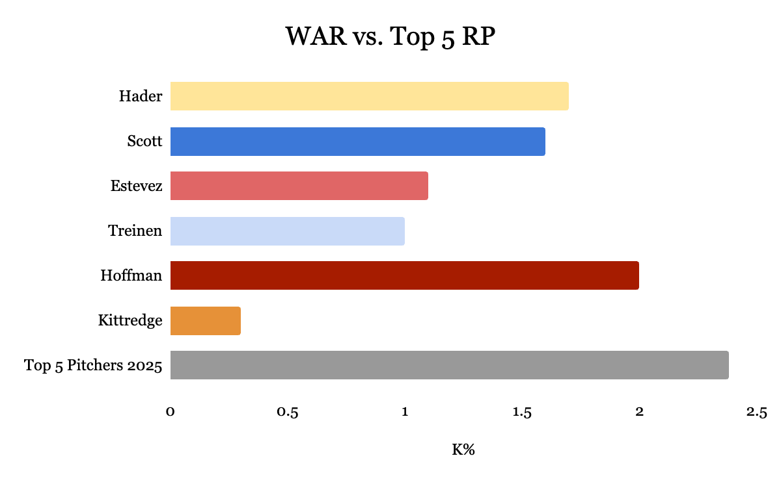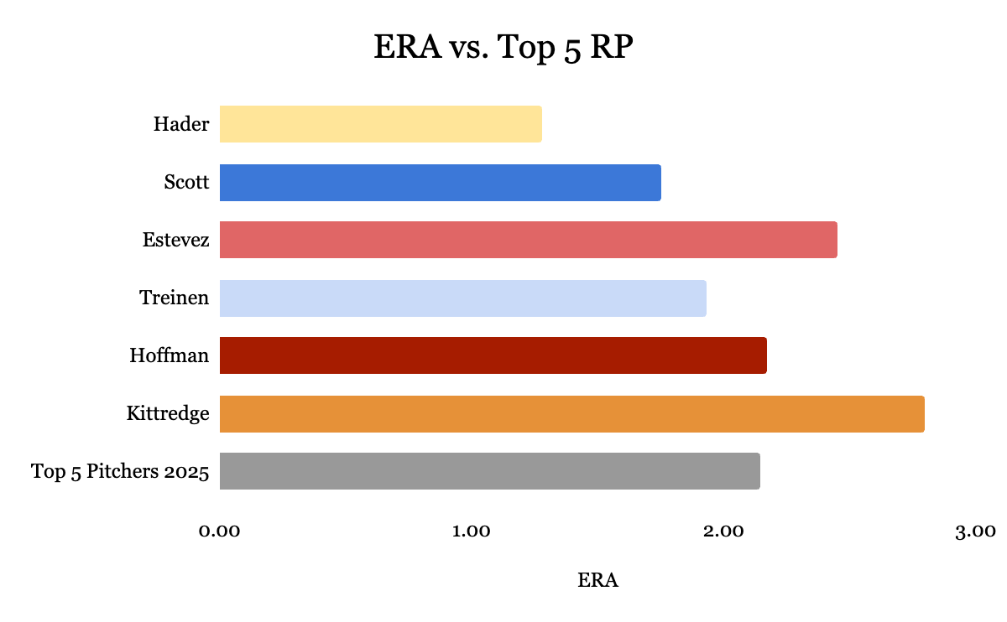
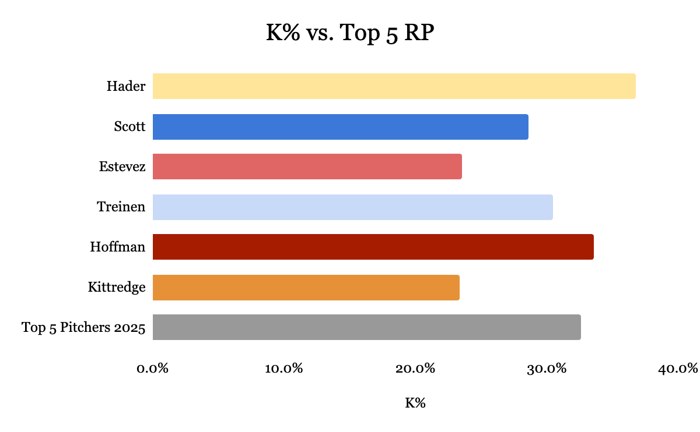

Across the above major statistical categories (WAR, ERA, K%) I have compared the individuals to the average of the top 5 relievers from 2025 on a WAR basis. Understandably, using WAR as a statistical measure may skew the chart, but it is meant to be illustrative of the clustering of these players near top performers. When looking at wins above replacement, all but Kittredge posted a WAR above 1. For context, in 2025 37% relievers achieved a WAR of 1 or above, and only 6% achieved a WAR of 2 or above. Clustered closely with the best in the league this past season, the WAR chart sets the table for guys like Hader, Scott, and Hoffman at how truly impressive their campaigns were before they signed their large contract. Primarily based on FIP, WAR can be a factor of situation, however a reliever with a high WAR points to their ability to limit contact and elite run prevention.
On the basis of Earned Run Average, the focus group was elite. With half of them posting a sub-2.00 ERA and all staying below 3.00, each one of these pitchers proved themselves in the top of the league at limiting earned runs. Hader, Scott, and Treinen beat the Top 5 Pitchers of 2025 by an average of .49 bps between the three of them, with no pitcher straying above .66 bps versus the Top 5 (sorry, Kittredge). Coupled with K%, where 3 players (Hader, Treinen, and Hoffman) struck out more than 30% of the batters they faced and all struck out almost a quarter of the batters they faced, it is not much of a question why these relievers were such highly sought after free agents. The ability to shut down a game in key situations is invaluable to a successful team, and with the stats presented above it is a logical conclusion that these key pieces to the bullpen would receive healthy compensation for their contributions in a contract year.

Part II: The Year After Their Contract
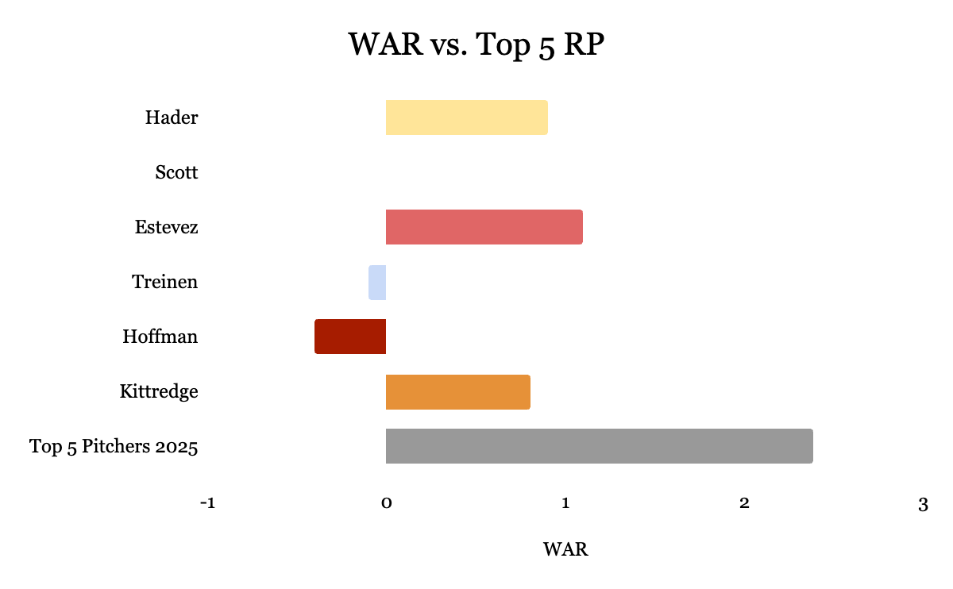

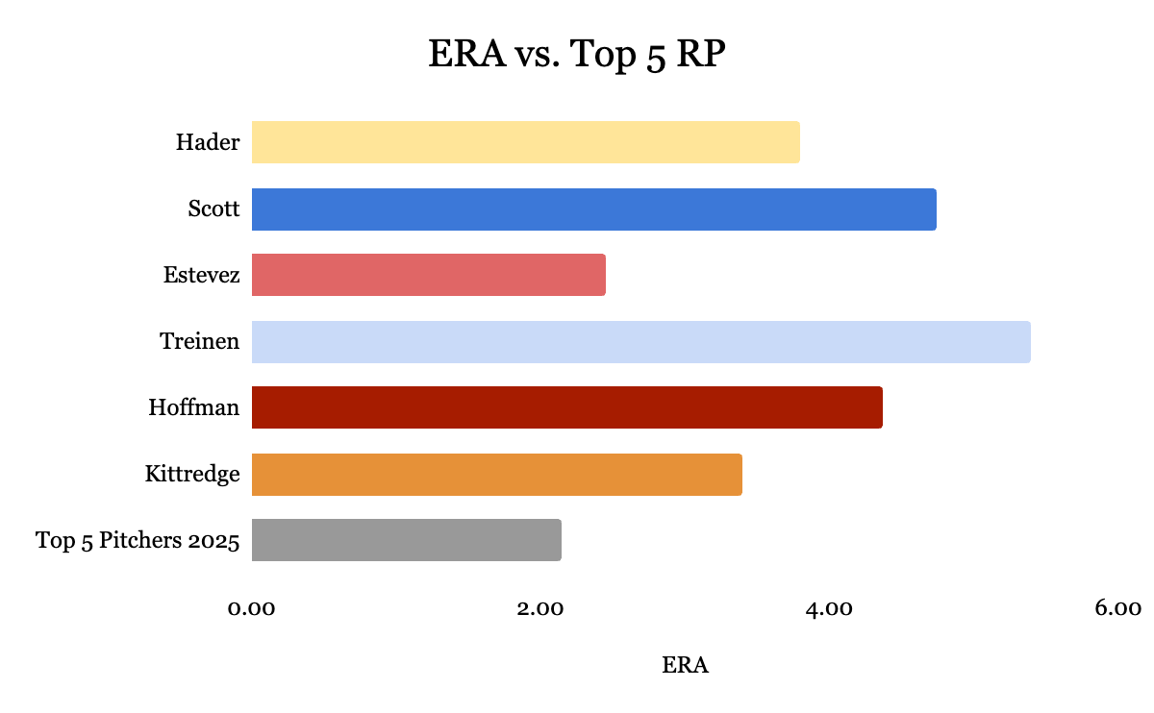
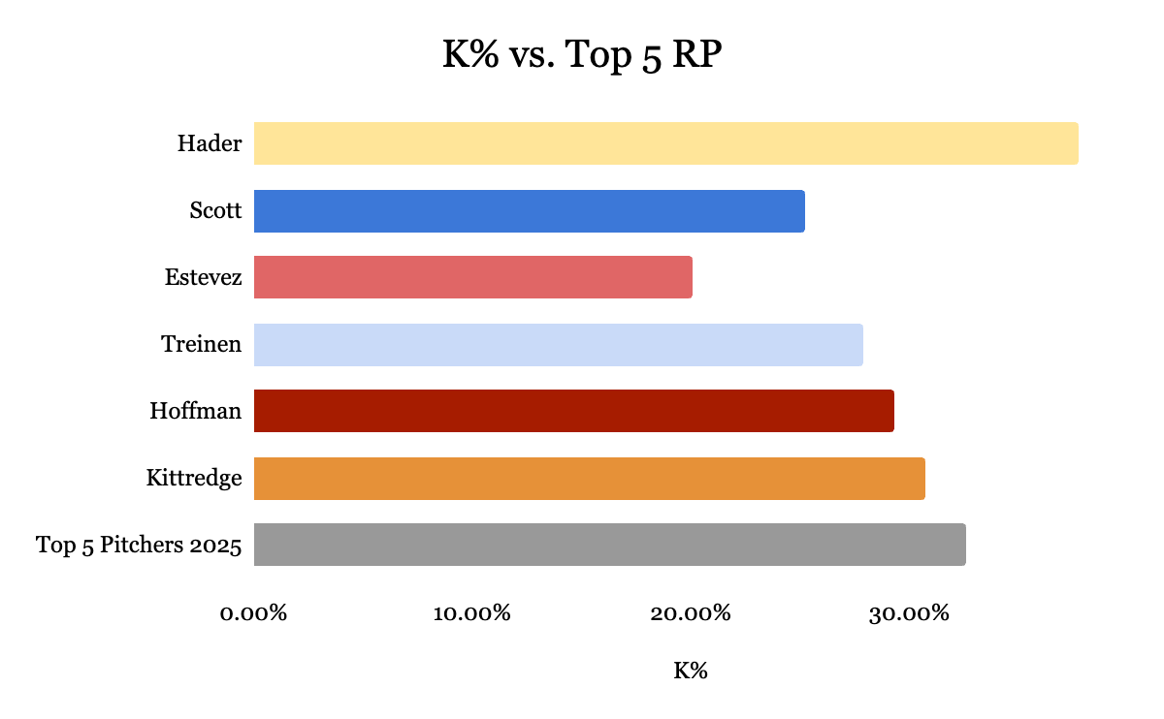
The results for each of these pitchers after their contract year are varied at best, and truly terrible at worst. In 2024, Josh Hader saw a nearly 200% increase in ERA, his WAR was nearly slashed in half, while his strikeout rate rose just 3%. A perennial threat out of the bullpen nearly his entire career, 2024 showed Hader may be human. Granted, he returned to all-star status in 2025 with a 2.05 ERA, 2024 was an outlier as a down point in Hader’s otherwise stellar career.
Tanner Scott this past year was another case of someone fans hoped would figure it out, but simply never found the rhythm he had the year prior. His 10 blown saves and 11 homeruns allowed were more than his 3 previous seasons combined as his saw his era climb 170%, his K% drop 30%, and his WAR fall in the negatives. Nobody on this list, and honestly no pitcher in recent memory, had more stark differences season to season than Tanner Scott.
Carlos Estevez is more of a success story. An all-star in 2025, Estevez maintained his performance across most major statistical categories, even with a downtick in his K/9 and an uptick in his BB/9 ratios. He maintained velocity on his fastball while leading the league in saves. A performance worthy of the large contract he received the offseason prior.
Dodgers fans, avert your eyes. Blake Treinen, another name with a lot of 0s next to it in the Los Angeles payroll books, had a similar downfall to Scott. After playing a crucial closing role in the Dodgers 2024 World Series run, Treinen was not nearly as effective in his 2025 campaign. Treinen saw an increase of 180% to his ERA, all while his K% fell 36% and his WAR fell 110% into the negatives. Through the 32 games he pitched, the story for Treinen lies in the free base with a BB/9 over 6.0 despite seeing improvements year over year in his fastball velocity and K/9 ratio.
Jeff Hoffman, who to his credit was a major factor in the Blue Jays journey to the Fall Classic in 2025, was terrible in the regular season. An increase of 100% in his ERA, a 120% drop in his WAR, and a 13% fall off in K% year over year paints the picture of his effectiveness in his campaign following his $11M AAV contract signing. His kryptonite: the long ball. With a 1.99 HR/9 and 15 homeruns allowed on the season, Hoffman struggled keeping a 0 in the box score. Nearly half of his earned runs allowed came from the long ball, as he allowed 33 earned runs on only 54 hits.
Finally, Andrew Kittredge, who saw some improvement in his effectiveness with a climb to a career best 0.8 WAR from his previous 0.3, still saw some dips in major statistical areas. His ERA rose 21% while his K% remained about flat. He was able to increase his K/9 while lowering his BB/9 and HR/9 rates (a good sign) but saw his LOB% drop over 10 basis points. Overall, no major signs of a “post contract year” fall off, but certainly not providing the production his paycheck would suggest (although important to note he earned $9M in 2025 with his Team Option exercised)

Part III: Conclusion
Let’s revisit the question: Are high performing relievers worth dishing out 8 figure contracts every season? The answer: it depends. Previous season performance is certainly not an indicator of future performance, especially considering the advancements in pitch tracking, video, and ability of hitters in the league. Forward projections can be misleading because they are exactly that: projections. As this study shows, in some of the leagues’ top arms a huge paycheck can be followed by anomalously bad seasons from perennial all-stars. Now I want to be careful not to overstate the negative findings. Pitchers like Carlos Estevez thrived after his payday and Josh Hader found his way back on the all-star roster a year after his tumultuous 2024 campaign. For every Craig Kimbrel there is an Aroldis Chapman (who has seen both good and bad seasons after a contract year). Perhaps the down season after a major contract is merely coincidence and can be attributed to several factors: new pitching coach, different location, age, better scouting, or a different catcher to name a few. However, looking at these relievers addresses a big concern for small market teams. Maybe the Dodgers can afford to miss on a reliever or two and have the payroll flexibility and talent to cover if performance falls. For other clubs, let these relievers be a cautionary tale. With limited budget and a virtual need to hit on big bets, maybe it is better to allocate those funds to a starter or consistent position player. With plenty of successful relievers appearing season after season from indy ball, the minor leagues, trades, and the draft, sometimes “homegrown” can be the best path forward for teams that need to squeeze every dollar out of the production on the field.

